**The Fourth Hampton Court Bridge**

[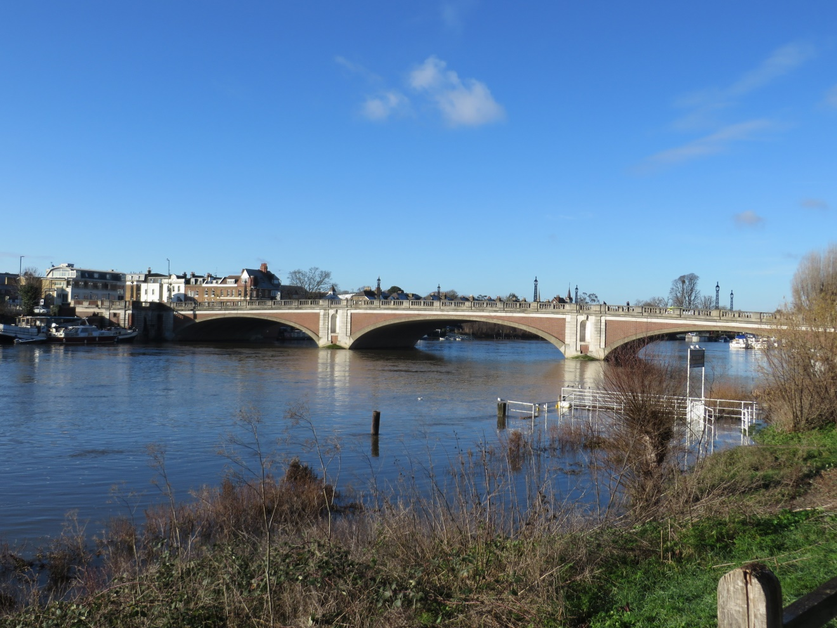](https://davidmeggittlog.ning.com/Hampton_Court_Bridge)

Hampton Court Bridge, River Thames, Near London

Some other books and publications by the same author.

*Modelling Life Cycle Costs for New Cities Overseas* for Asset Management News of the British Institute of Management

*Will the real project please stand up?* – Association of Project Management 2006/7 Yearbook   
(With Verna Allee)

*Co-creating essential business models – the VES handbook*  
(With Christie Sarri)

*Project management* – unicom seminar

*Using value networks to boost construction performance* – For Proceedings of The Institution of Civil Engineers (With Christie Sarri and Lilly Evans)

*How could “Open Government” transform its transparency? - Cultivating a new vocabulary for success in Greece and the UK –* Academia.eu

*Questions without answers (W*ith Christie Sarri) - Amazon

*Modelling innovation using the Value Exchange System (VES)* (With Christie Sarri) - Amazon

*Ecosystem Economics – How cool can you get?* Entrepreneur country – article

[*Does Doughnut Economics need star enterprises?*](https://enliveningedge.org/tools-practices/does-doughnut-economics-need-star-enterprises/) Article Enlivening Edge

[VES Newsletter](https://ves.ghost.io/)

To Cheryl

### 

**The Fourth Hampton Court Bridge**

**Organizational and Technical Design**

David I. Meggitt

BSc CEng MICE MCMI FRSA  
(Retd. MIMC MInstD MIHT)

**Technical Supplement to:-**

**“Hampton Court Bridge Through the Ages –   
The Story of the Crossings over the River Thames at Hampton Court.”**

**Published by the Molesey Local History Society**

Copyright © 2024 by David Meggitt

Published in the United Kingdom by David Meggitt, 23 Chestnut Avenue, Esher, Surrey, KT10 8JF.

First Edition, 2024

Copyright

All rights reserved. No part of this publication may be reproduced in any form, or by any means, electronic or mechanical, including photocopying, recording, or any information browsing, storage, or retrieval system, without permission in writing from the publisher. Permission **is given** to circulate the whole document in its entirety.

Disclaimer

Although this publication is designed to provide accurate information in regard to the subject matter covered, the publisher and the author assume no responsibility for errors, inaccuracies, omissions, or any other inconsistencies herein. This publication is meant as a source of valuable information for the reader, however it is not meant as a replacement for direct expert assistance. If such level of assistance is required, the services of a competent professional should be sought.

**Contents**

Preface 7

Introduction 8

Part 1 - Organizational Design 9

A Notable Collaboration 10

Part 2a - Technical Design: Superstructure 14

Fundamental Forces and Stresses 14

Concrete: History and Properties 19

Resisting Stresses and Arrangement of Reinforcement 20

Bridge Loading and Codes of Practice 21

Aesthetics and Structural Shape 23

Shaping up to the Bridge Self Weight - Dead Load 23

Influence Lines 24

Effects of Temperature Changes on Abutment Thrusts 26

Typical Worksheet for Computing Arch Reinforcement 27

Deck Expansion, Arch Deflection and Column Behaviour 28

Modern Analysis for Upgrade of the Bridge in 2022 28

Part 2b – Technical Design: Substructure 30

Cofferdams 30

The Influence of “Soils” on Substructures 32

Scour and Seepage under Cofferdams 33

Part 3 – Virtual Connections 35

Virtual work in structural analysis 35

Virtual worker in organizations 36

Importance of Working Relationships 37

A new Organizational paradigm 38

## Preface

David Meggitt has been a Chartered Civil Engineer for over 50 years. He was inspired to follow this profession after seeing at first hand the construction of the elegant Medway Bridge in Kent, UK, in 1960. After graduating at Leeds University and early construction work as an indentured engineer with Costain Civil Engineering, he joined firms of consulting engineers to learn the art of bridge design culminating in the design of the most highly skewed motorway bridge of its type.

Following this grounding, he pivoted his career to pursue management services, initially within the Project Planning Division of PA International Management Consultants and subsequently in the London office of Planning Research Corporation. This led to assignments in Hong Kong, implementing programme controls of the Initial Mass Transit System; The Kingdom of Saudi Arabia’s Ministry of Planning and the Royal Commission for Jubail and Yanbu; and Algeria’s Ministry of Planning.

A chance encounter led him to pursue over the next 20 years to the present time a novel business modelling approach and its extensions now known as the Value Exchange System (VES).

One of his interests is local history. He was volunteered to provide input to a project being undertaken by the Molesey Local History Society which was conceived to cover the history of the river crossings at Hampton Court. His focus was the planning, design and construction of the current fourth bridge.

This is being published in coloured hardback book form as “Hampton Court Bridge Through the Ages – The Story of the Crossings over the River Thames at Hampton Court.”

This digital document is an accompanying Technical Supplement to the book. It provides a very brief, but accurate, overview of pertinent theories available to the designers of the fourth bridge. In so doing, it is hoped to whet the appetite of the more technically minded student before launching into one of the exciting branches of the civil engineering profession, upon which one can boldly claim our civilization largely depends.

Any project depends upon the collective contributions of people fulfilling a variety of roles, and its successful outcome on fruitful collaboration between its participants.

It is, therefore, appropriate to include a small section on management and its evolution, including a playful piece on two aspects pertinent to both structural design and management; “virtual work.”

## Introduction

How often do we drive on a road that takes us smoothly over or below other roads, footpaths or railways without paying any attention? What amazing feat enables us to traverse waterways of modest size or of vast lengths? The answer is the bridge. How much more enjoyable would our trips be if we knew something about how they were built and can marvel at the elegance with which they bridge the gaps below them?

When travelling in slow moving traffic on a motorway, an upward glance at the underside of a bridge can reveal the huge variety of structural forms employed to leap the void.

“The creation of a great bridge is the most spectacular of all civil engineering achievements. Dominating the landscape, a bridge may make or mar its surroundings for centuries to come.”[1] Whatever its scale, a striving after beauty of form and harmony with surroundings is a social obligation bridge engineers recognise, and educate themselves to perform.

However, good taste in a structural design cannot be determined by mathematical equation alone, and artistic treatment cannot be standardized by any formal code of practice. So what is pleasing is often a blend of disciplines, typically combining those of the engineer and architect, both structural and landscape.

By exploring the history of the many bridges that crossed the River Thames at Hampton Court, and their impact on the surrounding area, we hope that the reader will gain yet further enjoyment from their journeys along a nation’s highways.

In total, four bridges have spanned the River Thames, connecting Hampton Court on the Middlesex bank, to East Molesey on the Surrey bank, and each bridge has, in its turn, made or marred its surroundings.

This document is a technical supplement to a book about the story of how the Thames has been crossed at this point, from the time when the Thames was tidal and ran free, to the planning, design and construction of the present Hampton Court Bridge.

The structure epitomises in its modest way a combination of historical technical  
innovations, yet hides them within a pleasing exterior that mirrors an even more historical heritage, that of the adjacent Hampton Court Palace and its Tudor origins.

Note that this is not a comprehensive technical guide, more a flavour of relevant aspects of the design of a reinforced concrete arch bridge at a river site, as undertaken in the 1930’s.

## Part 1 - Organizational Design

Civil engineers are possibly the unsung heroes of the modern world, using their brilliant creativity and expertise to design and construct some of the most awe-inspiring structures on the planet. Among these feats of engineering, bridges stand out as a shining example of the ingenuity and skill of civil engineers. Bridges are not just functional structures that help people travel from one place to another; they are also works of art that inspire wonder and admiration. From the elegant suspension bridges that span great rivers to the towering arches that cross deep canyons, civil engineers have pushed the limits of what are possible and created bridges that are as beautiful as they are practical.

Their skill has been extended to cover what are termed “mega projects.” For example, the construction of the first 80 miles of the UK’s M1 motorway paved the way for engineers to participate in programmes as large as the creation of entirely new industrial cities, or the development of interconnected transport links.

A question, therefore, arises. How are these feats organized?

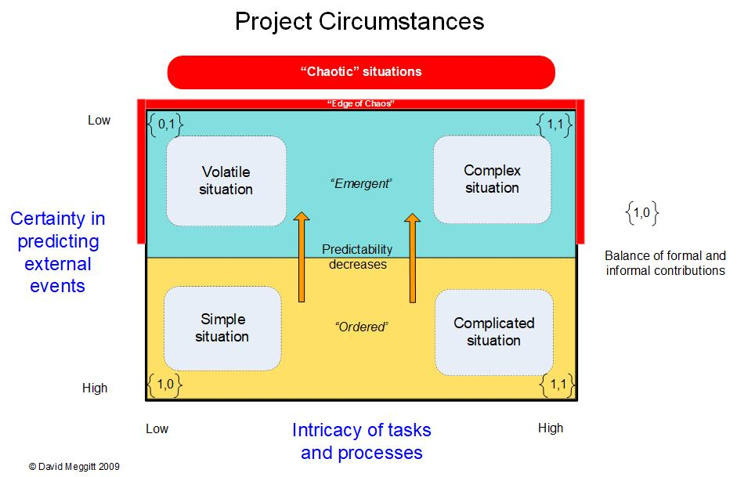A framework for categorising project circumstances is shown below.[2] At one extreme, the devastation of New Orleans in 2005 caused by flooding due to Hurricane Katrina would be a volatile situation, bordering chaos, as is providing humanitarian relief in wartime city zones. The creation of the current Hampton Court Bridge would, however, be a simple situation, **despite using methods novel at the time: in part due to enhanced collaboration between Participants.**

### A Notable Collaboration

The main players in the development of the current Hampton Court Bridge are shown below. Significantly, Mouchel and Holloway had worked previously on the creation of the much larger Royal Tweed Bridge at Berwick-upon-Tweed (UK). This enabled both organizations to establish a degree of trust that would be helpful in their second and final joint bridge project.

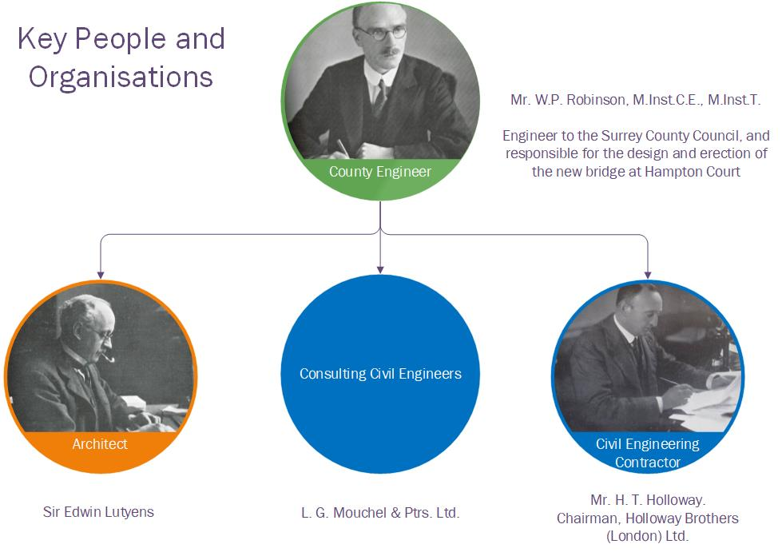

This second collaboration between Mouchel and Holloway represented a significant early departure from the traditionally adversarial relationship between consultants and contractors that once dominated the construction industry. Historically, and until the 1990’s the dynamic between these parties was marked by rigid roles and frequent conflicts of interest, often leading to inefficiencies and delays.

The introduction of the NEC (New Engineering Contract) series of contracts signalled a transformative approach, fostering more collaborative and less contentious relationships among project participants. This shift, highlighted in recent papers presented to the Institution of Civil Engineers (ICE)[3], underscores the evolving understanding of project ecosystems as complex and interdependent business networks.

Traditionally, projects were seen as isolated endeavours managed by distinct organizations with clearly defined, hierarchical relationships. However, the modern perspective views these configurations as part of a dynamic value exchange system, where collaboration and flexibility are paramount. This transition has been partially accelerated by the recent COVID-19 crisis, which necessitated a mix of traditional office work and virtual collaboration, challenging preconceived notions of organizational boundaries.

Looking ahead, advancements such as remotely operated robotic machinery on construction sites will further redefine the nature of work and collaboration in the industry. In response to the ongoing productivity crisis, there is a growing recognition that greater organizational agility can be achieved through increased personal agency and autonomy among workers. This evolution reflects a broader shift from mechanical, process-driven models to more organic, adaptable and emergent structures.

The NEC3 suite of contracts provided various options for structuring interrelationships between participants, enabling a more collaborative and integrated approach to project delivery. This framework encourages the development of partnerships based on trust, shared goals, and mutual benefit, marking a significant evolution from the adversarial practices of the past to a more cooperative and productive future.

The concept of "We Spaces"—an idea rooted in neuroscience—further offers significant insights into how and why people interact within organizations. It highlights the potential to transform traditional organizational charts, used in construction, into models centred on key participants, each playing a crucial role in a value exchange system.

### Examples of Major Works by Team Members

|  |  |
| --- | --- |
| Team member | Works |
| Sir Edwin Lutyens | British Ambassador’s Residence, Washington D.C., U.S.A.  British Medical Association, Tavistock Square, London  Castle Drogo, Devon  Cenotaph, Whitehall, London  India Gate, Delhi, India  Memorial to the Missing of the Somme, Thiepval, France  Midland Bank Headquarters (former), Poultry, London  Midland Bank, King Street, Manchester  Reuter’s Building, 85 Fleet Street, London  Viceroy’s House, now Rashtrapati Bhavan, Delhi, India |
| Holloway Brothers | Bridges  1914 Esk Bridge Gretna, replacing one built by Thomas Telford in 1820  1922-6 Bridge over the Thames at Reading  1924-8 Royal Tweed Bridge at Berwick-upon-Tweed  **1930-3 Hampton Court Bridge**  1934-7 Chelsea Bridge The first self-anchored suspension bridge in the country and the first steel bridge built by Holloways  1936-7 Towy Bridge at Carmarthen  1936- King Ghazi and King Faisal Bridges across the Tigris at Bagdhad  1936-40 Wandsworth Bridge  1939- Bahrain swing bridge  1945-50 Baghdad combined road-rail bridge across the Tigris  1956-8 bridge over the Diyala River at Baqubah Iraq.  Additionally: buildings, other civil engineering works, restoration of historic buildings, memorials and similar  projects.  https://en.wikipedia.org/wiki/Holloway_Brothers_(London)#Bridges  accessed 5th October 2020 |
| L G Mouchel | Bridges [4]  Of 414 known reinforced concrete bridges built in the British Isles between 1870 and 1914, Mouchel were responsible for at least 300, commencing in 1901, of which 59 still exist.  Additionally, major structures including:  Royal Liver Building in Liverpool  London's Earls Court and Royal Victoria Dock  Football stands for Liverpool Football Club and Manchester City Football Club  Cooling towers for London Battersea Power Station  Also see:- https://en.wikipedia.org/wiki/Mouchel  accessed 5th October 2020 |

## Part 2a - Technical Design: Superstructure

### Fundamental Forces and Stresses

The fourth bridge at Hampton Court consists of two types of concrete structure - central piers which are primarily mass structures, supported on piles, and the arches which are framed structures. The former resist loads on them, mainly due to the arrangement of their overall weight, whilst the arches resist loads and their self-weight, by careful configuration of their geometry.

The arches, which are made of reinforced concrete, withstand three types of force:

* Forces perpendicular to the direction of span (or its axis) called shear forces - V
* Forces which act along its length (such as in columns or struts) called axial or normal forces - N
* Bending actions, called bending moments – M

Arch members may also experience twisting moments (or torsion), but these would be considered negligible, and therefore not taken into account in the calculations.

The application of any of the above forces, either singly or in combination, will cause movement (deflections), however small. It is these movements that create stresses in the structural member experiencing the forces.

Reinforced concrete arches can experience all the above forces and are complicated to design. Rigorous methods were only being established in the early 1900s. These were based on earlier work in the mid-1800s by Navier, Castigliano, and Rankine, who had applied their theories to investigate the behaviour of masonry (voussoir) arches.

The simplest structure is a straight beam (or member) spanning between two supports at its ends. It will sag slightly under its own weight and with any additional applied loads. If it is free to rotate at its ends, it will sag more than if it were held tight at the end. The former is called “simply supported” and the latter, “fixed” (or encastré.) In practice, beams can span continuously over several supports, which complicates how forces are distributed. At Hampton Court, the ends of the arches are fixed into the piers, and each arch can be considered separately from the adjacent ones, the two side spans being shorter than the central one.

In an element of a beam, the forces shown diagrammatically below (a point load P and uniformly distributed load U) create stresses internally at any section along the beam’s length.

M1 and M2 represent bending moments, and V1 and V2 represent shear forces. All these must balance out and the material forming the structure must resist the stresses arising.

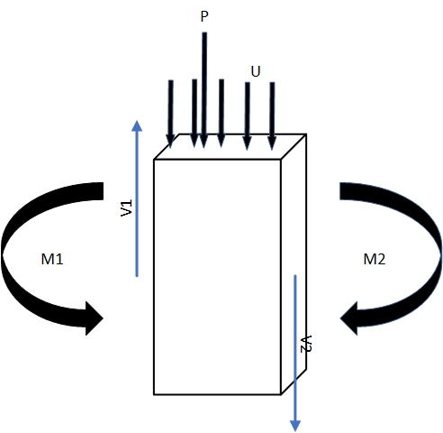

Forces on an element of a beam

The calculation of the forces for a simple beam are straightforward although in a bridge many combinations of loading must be considered, both dead load (the weight of the finished structure) and live loads imposed by traffic. Calculations for the encastré arches at Hampton Court would have been very much more complicated as it is a statically indeterminate structure. It also has varying distributed dead loads due to the changing depths along its length and (in theory) varying point loads from the vertical column struts they supported. Although graphical methods were no doubt used, the theory available at the time used mathematics' calculus and algebraic equations to calculate axial forces, bending moments and ultimately shearing forces in the rib and the thrust on the piers and bridge abutments as shown in the illustration below.[5]

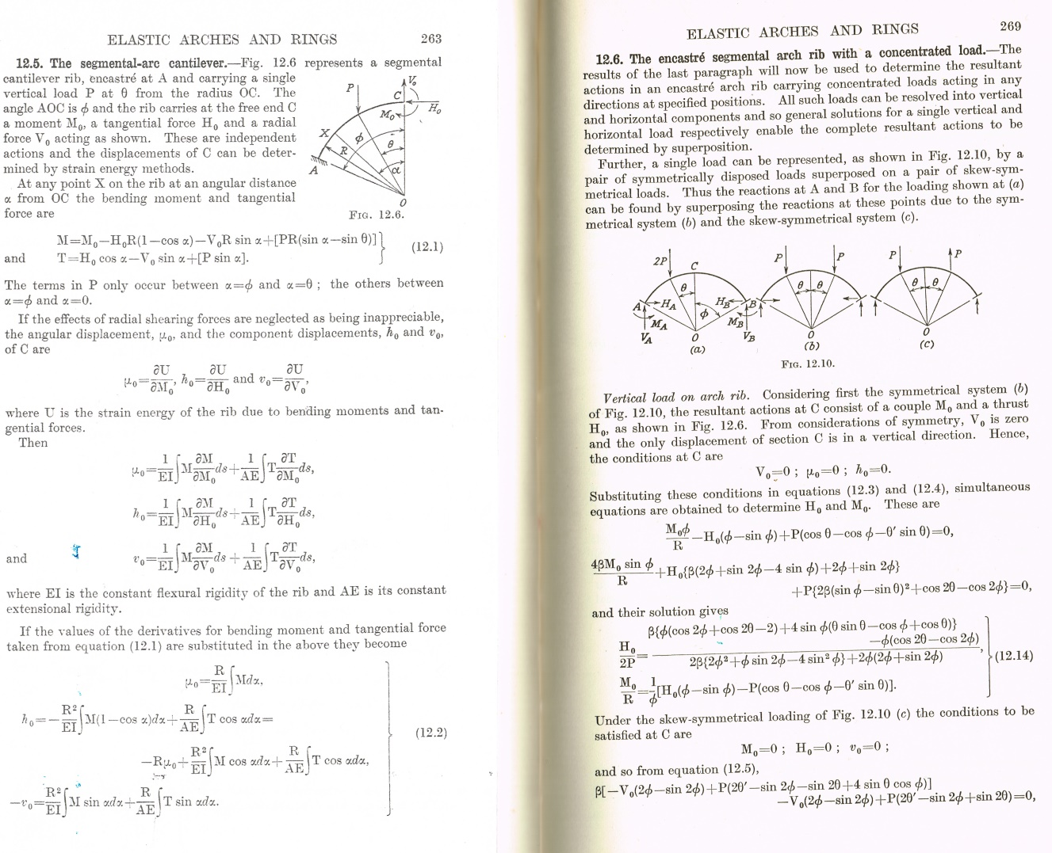

Typical theoretical treatment for arch computations

Influence lines may also have been used to compute the variation of, for example, bending moments near the piers due to changes in vertical loading from the column struts. Interestingly, due to their encastré nature, more reinforcing bars were placed at the piers than at the crown centre of the arch rib. This may be because the bending action can be greater at the supports than at the mid span, although in reverse direction.

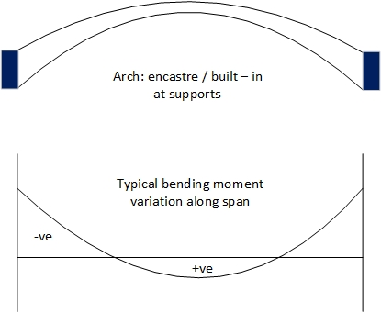

Typical variation of bending moment under dead load for encastré supports

This does oversimplify the behaviour of the structure. Modern computerised methods can take into account the way in which loads would be distributed not just along but across the bridge deck and its supporting beams before transmission to the arches via the struts themselves.

Another challenge is that the arch structure only has strength when it is finished. Consequently, the centring used to support the reinforced concrete arches during their construction needed to be of an arch shape as well. Albeit of lighter construction, this added significantly to the overall cost. At Hampton Court, prefabricated steel arches were used for these temporary works, and were designed as simply supported beams, both for relative simplicity, and to eliminate horizontal thrusts at the supports.

The distribution of stresses, due to the above forces, at any section of even a simple beam can be extremely complicated. The following, however, provides a broad outline of what is happening and, consequently, why reinforcement is placed in concrete.

Firstly, stresses from the action of bending under its own weight, or an applied load P, arise as shown below. With a beam deflecting downwards due to such loading, the top section of the beam is in compression and experiencing compressive stresses. The bottom section is in tension and experiencing tensile stresses.

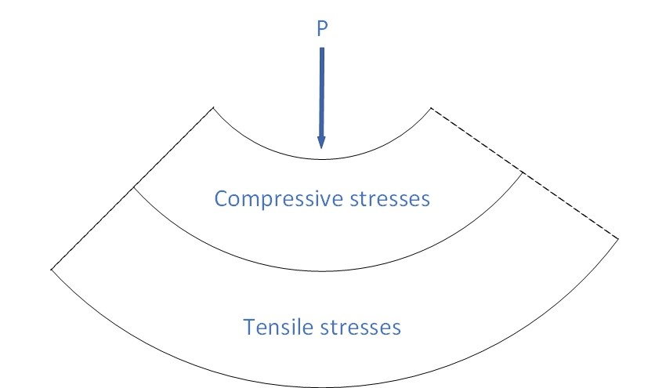

Zones of compression and tension in a beam bending under vertical load

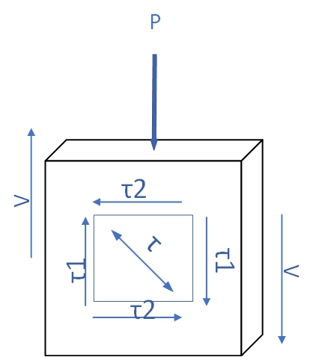Secondly, shear forces at any point in the beam must balance out.

Shear forces and stresses in a beam under vertical load

Shown above, is a small element within a beam. The external load, P, creates within the element the forces, V. In turn, V creates the internal stresses, τ1, balanced by complementary stresses, τ2. A resulting stress, τ, is a tensile one. This reaches a maximum at a certain orientation, and is called a diagonal principal tensile stress.[6]

Hence, tensile stresses arise from both bending and shear forces.

Stresses also arise due to movements (deformations) in structures. Some are reversible, such as those caused by applied loads. Under constant load, concrete suffers from permanent displacement due to creep. Thermal movement also occurs due to variations in atmospheric temperature overall, and temperature differences over its surfaces. Finally, as concrete dries out, it shrinks. Usefully, however, this last movement is the main contributor to the bond established between concrete and any reinforcement added enabling the strength in the steel to be mobilised.

### Concrete: History and Properties

The creation and use of concrete has a long history.[7] For example, a form of concrete, pozzolana, was used in Roman times, which initially incorporated volcanic material around Pompeii. Being of plastic constituency, it was recognised that this material could be poured into three dimensional shapes. Consequently, it became much cheaper to use than the cutting of stonework into precise shapes. In the UK, a significant advance was made in 1859. After a long series of tests, an artificial cement (Portland cement) was used in the London main drainage works, engineered by John Grant. In 1898, "Concrete Bob" McAlpine designed and built in mass (unreinforced) concrete the Borrowdale Bridge and the Glenfinnan Viaduct for the West Highland Railway.

A concrete mix is designed so that the concrete end product is suitably workable for the environmental conditions under which it is placed - too little water creates an unworkable mixture, whilst too much water reduces its strength. It also has to achieve the specified strength within the required timescale, and be free from internal holes (voids) by having:

* sufficient cement to fill the voids between the fine aggregate particles (sand), which creates a dense mortar,
* sufficient mortar to fill the voids between the coarse aggregate particles,
* the addition of admixtures.

The aggregates themselves are selected with regard to some nine different factors. For example, at Hampton Court, five different concrete mixes were used in the bridge design. Currently, new obligations to decarbonise concrete have introduced additional complexities.

A key problem with concrete is that, although it is strong in compression, it is particularly weak in tension.  Concrete at Hampton Court would probably have been specified to have a working compressive strength of some 1,000 lb/sq. in. This will crack in tension at around 300 lb/sq. in, although its ultimate crushing strength in compression could be nearer ten times greater at 3,000 lb/sq. in. Hence, concrete alone is useless for members subjected to bending, since failure would occur at very low loads in regions where tension is developed. This limitation can be overcome and the necessary resistance to tensile stresses significantly enhanced by inserting steel rods in tension zones. Rods can also be placed in a member's compression zone to supplement further the resistance provided by the concrete alone. The rod reinforcement used at Hampton Court is of mild steel and has a permissible working tensile strength of some 20,000 lb/sq. in.

This composite structure is known as reinforced concrete and is made practicable by two fortunate circumstances. Steel and concrete have almost two identical coefficients of expansion, so that no serious internal stresses are set up by temperature changes. Further, when concrete sets in air, it contracts and firmly grips reinforcement embedded within it. Consequently, loads are shared very effectively between the two materials, and in such an ideal manner, that design theory is greatly simplified.

### Resisting Stresses and Arrangement of Reinforcement

Any structure can have a combination of the three force actions described above. Within the arch ribs at Hampton Court Bridge, we can see the arrangement of reinforcement used. These will have been designed to resist bending actions, shear and axial forces, whilst neglecting the effects of any torsion.

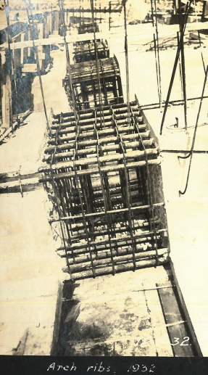The photograph shows main reinforcing bars at the top and bottom of the ribs. In total, 32 bars were placed at the encastré supports, with 20 bars placed at the centre of the span. The vertical stirrups help not only to keep the rods in place before concreting but also to resist the vertical components of the principal tensile stresses due to shear. These are spaced more closely together when the forces are greater. It is also common practice to resist shear, most particularly in beams, by bending up bars from the bottom layers to the top layers, as shown diagrammatically below.[8]

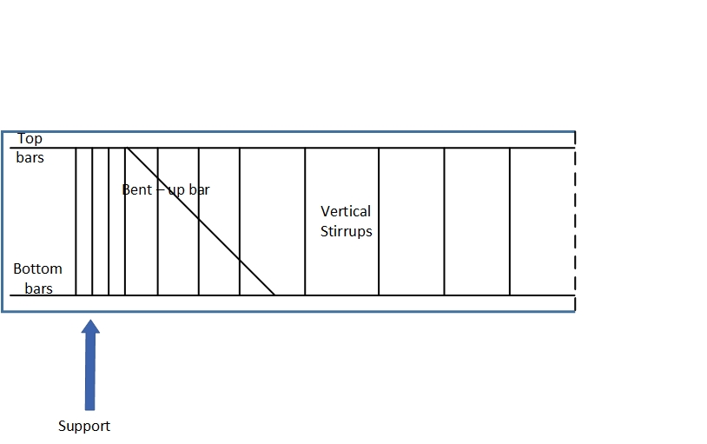

Typical arrangement of reinforcement in beams to resist shear

Reinforcement can be used in myriad ways. For example, it is also used to help control cracking due to shrinkage in deck slabs, and to strengthen concrete further in struts and piles under compression.

### Bridge Loading and Codes of Practice

*“Prior to 1910, highway bridge loadings were specified by local authorities which took into account “normal traffic of the district,” with tests on the completed bridge carried out by running steamrollers over them. The introduction of standards commenced in 1922 when the Ministry of Transport published its requirements following recommendations made in 1918 by a joint committee comprising the Concrete Institute and local government engineers. This included a standard loading train of a tractor pulling three loaded trailers. The aim was to produce bridges which would last 100 years without strengthening to accommodate the then unknown increases in traffic.*

*In practice, however, the combined loadings were found to be too heavy. After engagement with the construction industry, alternative, less severe French and American loadings were selectively used in design from around 1925. By 1931, the Minstry of Transport issued its guidance in September in the form of an equivalent loading curve, relating a decreasing uniformly distributed live load (from traffic) to increasing span, and the approximate amount of reinforcing steel bars laid parallel to the supports as a proportion of the main longitudinal reinforcement. Theoretical approaches for analysis were also proceeding at a pace. Influence lines for determining live load distributions were regularly used and by 1930 technical papers and standard text books published on how to treat the distribution and effects of different types of loading on flat slabs. This contributed to bridge engineers’ understanding of the real behaviour in bridge decks.”* [9]

To assist in the design of reinforced concrete structures, Codes of Practice were progressively developed. Approaches to the design have changed considerably since the first national Code of Practice for reinforced concrete was published in 1934 (D.S.I.R.) with a first revision in 1948 (CP114), and the first guidance for bridges issued by the Ministry of War Transport in 1945. Further significant advances include the practice of prestressing concrete which aims to stress the members artificially to a state of compression, so that under conditions of superimposed loading, the normal tendency for tensile stress to develop only goes to nullifying the artificial prestress. The first code of practice for prestressed concrete was published in 1959 (CP 115). The first unified code for the structural use of concrete was published in 1972 (CP110), although withdrawn in 1985 and its successor BS8110 published in 1997. The standard as at 2021 for bridges is Eurocode 2 introduced in April 2010.

### Aesthetics and Structural Shape

An aesthetic bridge usually has the following characteristics. The design suits the particular conditions existing at the site, and the materials used must be appropriate for the adopted design. The bridge as a whole, and in every part, must look what it really is. This means that the proportions, masses and lines of the bridge must be beautiful, and the texture and colour of the materials must be pleasing. The ornament and architectural treatment of the bridge must be suited to its materials, and must harmonize with its surroundings in both general design and colour.6

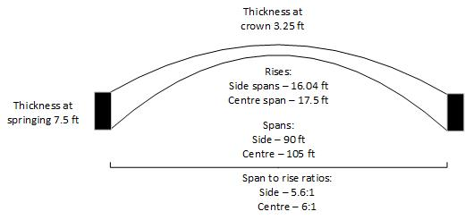Structurally, important factors affecting arch design are the span to rise ratio, and its shape. The latter is generally one of three types, segmental (or constant), parabolic, (which is most often used), or elliptic. At Hampton Court the shape is elliptic, and the overall span characteristics are as shown in the figure.

Key dimensions for arches in Hampton Court Bridge

It is generally uneconomical and almost impracticable to construct arches with a span-to-rise ratio greater than 10:1. Not only does it begin to appear very flat, but enormous thrusts arise at the abutments which may cause them to move and invalidate the assumptions used to design the arches. A range between 3:1 and 6:1 is normally selected for economy, with Hampton Court being at the latter limit.

The way the thickness of the arch varies between the springing to the crown is also significant. At Hampton Court, the thickness at the springing is 2.3 times the thickness at the crown, slightly outside the normal range of 1.5 to 2.

### Shaping up to the Bridge Self Weight - Dead Load

For many centuries structures of arch form have been in use, made up of wedge-shaped blocks of masonry known as voussoirs. Although not necessary for their stability, the blocks were usually set in jointing material of mortar or cement. The shape of the arch and strength of the abutments alone determined its stability. The central aim was to contain the forces due to its dead load within the arch, which ensured that tensile stresses were avoided.

Mathematical theories for evaluating structural behaviour were only rigorously being developed during the nineteenth century. Nevertheless, lessons from this time were carried over in assessing the behaviour of arches made of materials which possessed both compressive and tensile strength - structural steel (as in the third Hampton Court Bridge) and the current one made of reinforced concrete. With all types of arch, bending moments due to dead load can be eliminated when the dead load thrust line coincides with the arch axis throughout. The rediscovery, this century, of Young’s nineteenth century design method for this condition also demonstrated this theoretically. (The exception to this is the condition known as “rib shortening,” in arches fixed at their abutments.)

### Influence Lines

The simplest and safest way to analyse all types of arch was by employing influence lines. Ideally, these should have been constructed from “first principles” without making unnecessary or unreasonable assumptions. Each line for an influence line is drawn for one point only of the structure, to give one of the selective forces (bending moment, shear etc.) the value of that force at that point, for different positions of the load. Compare that to a bending moment diagram, for example, which gives the bending moment at all points for one position of the load.

Although the geometric shape of the arch is not identical to that at Hampton Court, its influence line profiles could well have been similar to those shown in the figure below. These show the bending moment at the springings (Ms), bending moment (Mc) at the crown, A, and horizontal thrust (Hc) at the crown.

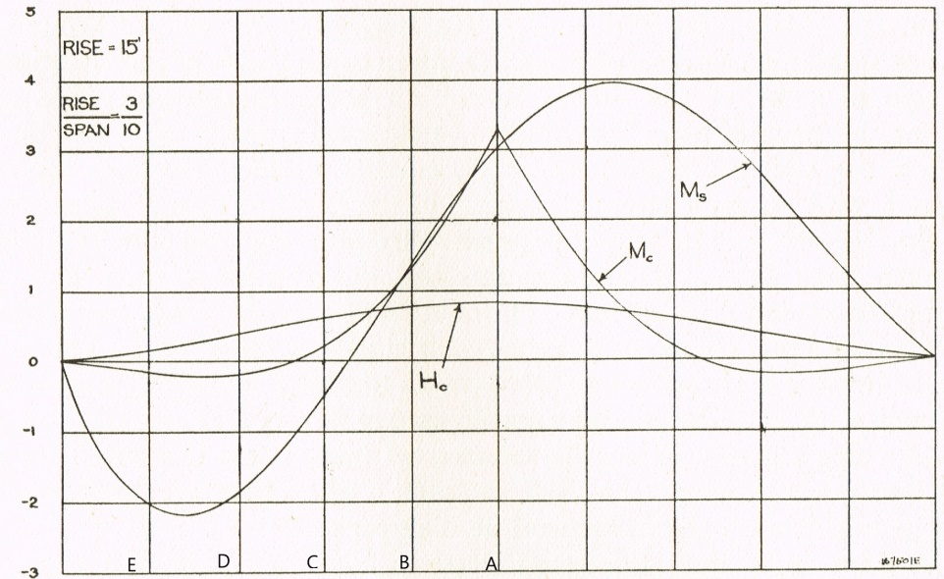

Typical influence lines for stated bending moments and thrust for an encastré arch

For example, both Mc and Ms change direction as the load traverses from the left hand side, through the centre of the span at the crown, to the right hand side of the span; the horizontal thrust at the crown remaining positive throughout.

Once the dead load is determined and distributed along the entire span, it remains unchanged. The positioning of the live load, however, requires many options to be considered and the influence lines show where they should be placed to create the most severe bending moment cases, both positive and negative.

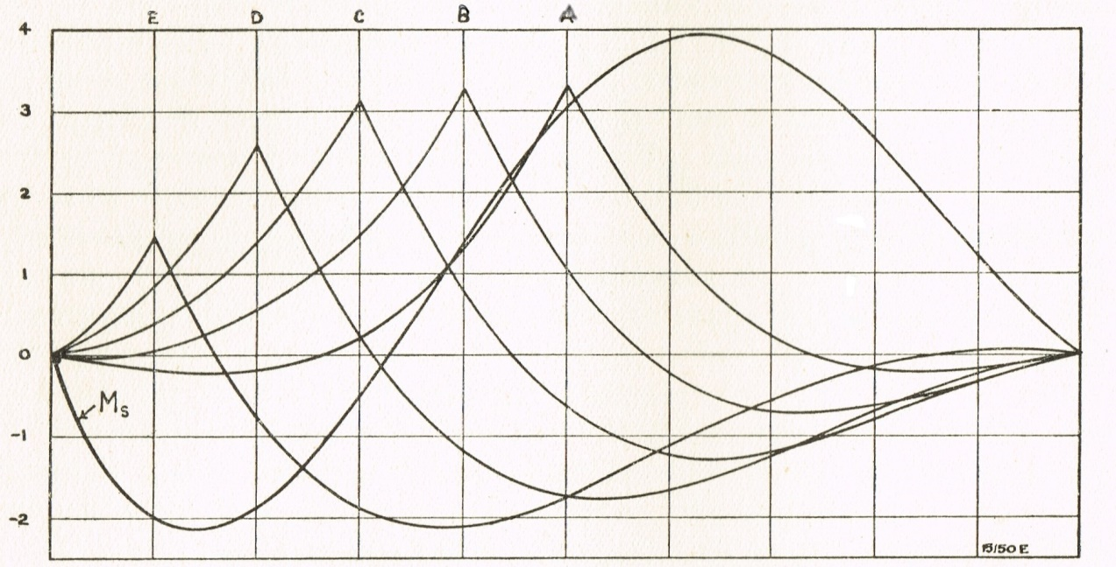Influence lines also need to be calculated for different positions along the span. For example, at locations A to E, each curve is for a section vertically below its cusp.

Bending moment influence lines for different sections (A to E) and support of an encastré arch

When arches become flatter, the horizontal thrust (Hc) at the crown begins to increase exponentially. This requires the abutments and intermediate piers to be progressively more resistant to any movements that this tends to induce.

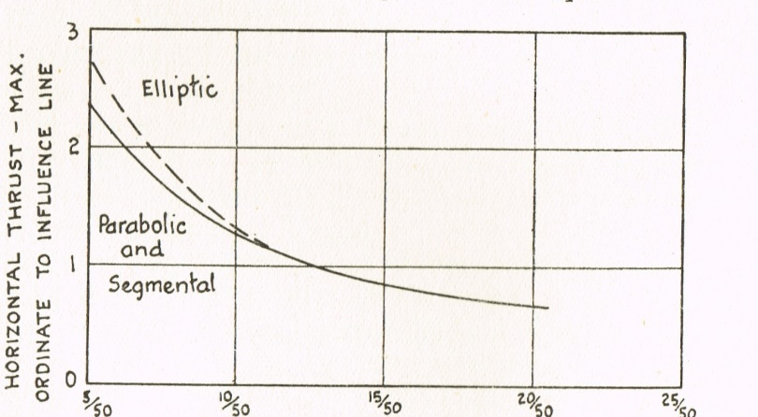

Flatter arches induce increased horizontal thrust

### Effects of Temperature Changes on Abutment Thrusts

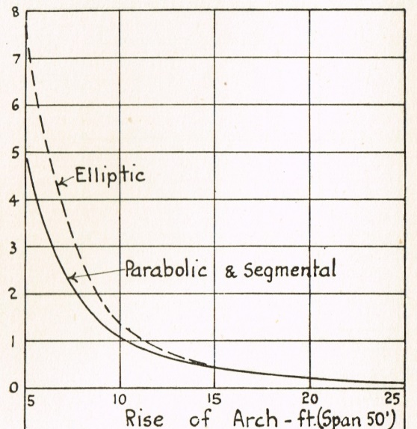The temperature range usually considered in design was plus or minus 30 $℉$ above or below the normal temperature for a bridge’s location. Thrusts on the abutments due to temperature changes, and additionally shrinkage and rib shortening, also mount rapidly as the arch becomes flatter. Consequently, a rise-to-span ratio of 1:10 could reasonably be taken as a low limit. This is shown on the left-hand side of the figure below, which represents the variation of thrust at the abutments for a fixed arch. For example, the thrust on the abutments of a parabolic arch could increase five times as the span-to-rise ratio is just doubled from 5:1 to 10:1.

Typical relative change in thrust on abutments due to temperature changes as arch becomes flatter

*“The thrusts on the abutments become so large that the difficulties are not confined to the arch ring itself. As the arch section is increased to cope with the increased stresses, this results in its moment of inertia increasing, and at approximately the cube of its thickness. This draws additional internal moments towards it and the total stresses are further increased. Adverse temperature effects are also compounded. There comes the stage when an increase in section results in an unmanageable set of these fibre stresses under a combination of the most unfavourable circumstances. It therefore pays to keep the depths of the section down to a minimum, and to use a fairly large percentage of reinforcement.*

*Thus the variation in thickness of the arch ring is of importance. Stress requirements indicate that the springing thickness should be usually from 1.5 to 2 times the thickness at the crown. As the rise to span ratio increases, the required increase in springing thickness above that at the crown decreases, and with a large rise to span ratio, very little increase is required. For flat arches the 50% increase (1.5) is insufficient, and the springing thickness in some cases will need to be more than twice that at the crown.”* [10]

This is due to redistribution of internal moments as indicated above, and consequently its stiffness.

Inadequately mitigating the effect of temperature stresses can ultimately induce failure in structural members. This may well have contributed to the unserviceability of the relatively flat third bridge at Hampton Court.

### Typical Worksheet for Computing Arch Reinforcement

Clearly, the analysis of the structure needs to be rigorous. In the absence of anything but slide rules and electro-mechanical computation machines available in the 1930s, systematic methods were essential. This required the mathematical stages to be broken down into manageable chunks.

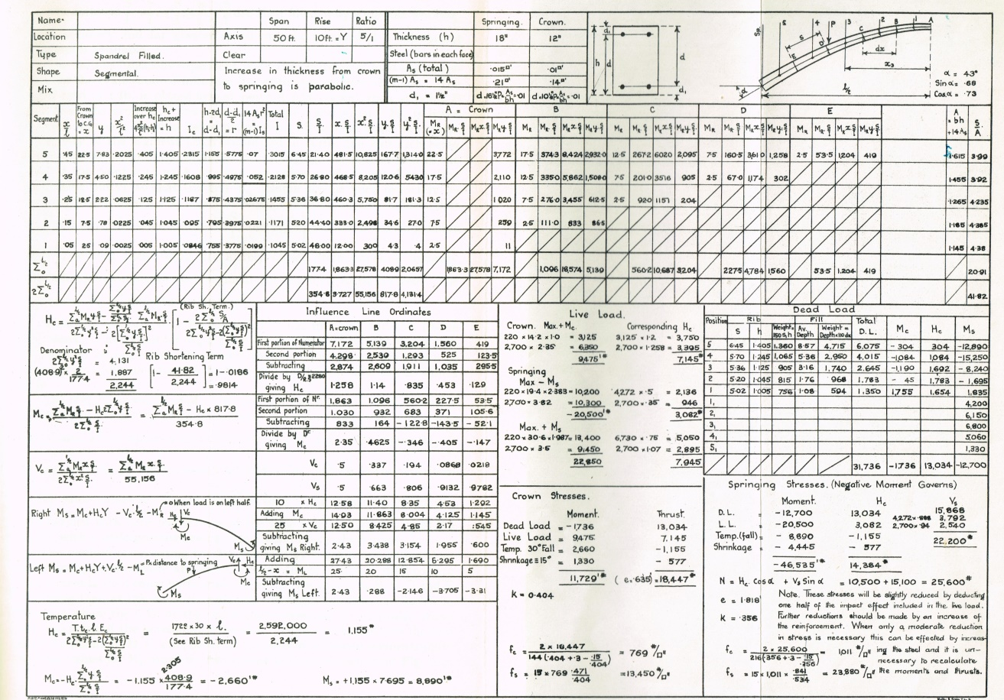An example of the format for calculations which may have been used for the arches at Hampton Court is shown in the figure.

Typical single sheet arch calculations

The equations used are the result of prior extensive mathematical calculations.1 The point loads along the arch, as displayed in the top right hand corner of the sheet, represent the loads imposed by columns. These provide support to combinations of cross beams which, in turn, span across other columns. The beams need to be stiff, compared with the columns, and the bending moments in those members could well have been determined by the Theorem of Three Moments developed by Clapeyron in 1857.

### Deck Expansion, Arch Deflection and Column Behaviour

**T**he arch ends are fixed so that the span length cannot vary, assuming no movement of the abutments. However, since the arch is flexible, temperature changes result in a rise or fall of the crown.  Live loads cause similar movement. Also, the deck should be free to expand and contract. Expansion joints are provided for this purpose and located over the substructure supports.

*“The elastic movement of the arch itself will be somewhat restrained by the columns and beams and by the monolithic construction with the deck at the crown, but expansion joints in the deck will limit this restraint. On the other hand, expansion and contraction of the deck between expansion joints will induce bending moments in the columns. Bending moments in these members are also developed as a result of deflections in the deck arising from the varying live load. The longer columns are also more flexible.*

*It is generally desirable to keep the direct stress in all the columns fairly low to allow for the secondary bending stresses which would not have been accurately calculated. It is also advisable to detail diagonal shear bars at both ends of the column as the maximum moment and shear at these locations occur together.”* 6

The effect of these loading and stress interactions had been the subject of experimental research at the University of Illinois in 1931.

### Modern Analysis for Upgrade of the Bridge in 2022

The structural assessment for the 2022 maintenance works referred to earlier utilises the appropriate sections of the Design Manual for Roads and Bridges. This forms part of a suite of technical documents produced by the UK’s National Highways organization covering design, contract documents, maintenance and operation of highway network assets, and undergoes continual revision to incorporate new research findings. Whereas elastic designs, as originally used, are not *predictions* of structural behaviour under varying conditions and methods of construction, they *do* provide a set of stress resultants which are in equilibrium. This results in a safe and conservative design. However, in structural assessment, one is attempting to predict the *actual* behaviour of an existing facility, using section properties that are fully defined. Hence, there is scope for more accurate analysis.

To achieve this, a wide variety of analytical approaches (modelling) can now be used to assess bridges, ranging from simple static load distributions, through conventional elastic analyses as above, to sophisticated non-linear analyses. In modelling the Hampton Court Bridge, a three-dimensional beam element model was selected which used Finite Element Analysis (FEA) software.

*“The deck was analysed as a linear elastic grillage shown in the figure below consisting of two-way spanning slabs supported by T-beams and L-beams. The slab is continuous over the beams. The columns were considered as fixed both ends. The arches were modelled with fixed boundary conditions at the supports. At the piers, the support will be located at the point where the centre line of the arches coincides. The blockwork provided near the expansion joint in the deck was modelled using beam elements and will be pinned at each end. The deck was considered as torsionless while the arches were considered to have full torsional stiffness. Section properties and capacities of the reinforced concrete members were calculated in accordance with BD 44/15 using gross elastic uncracked section."*[11]

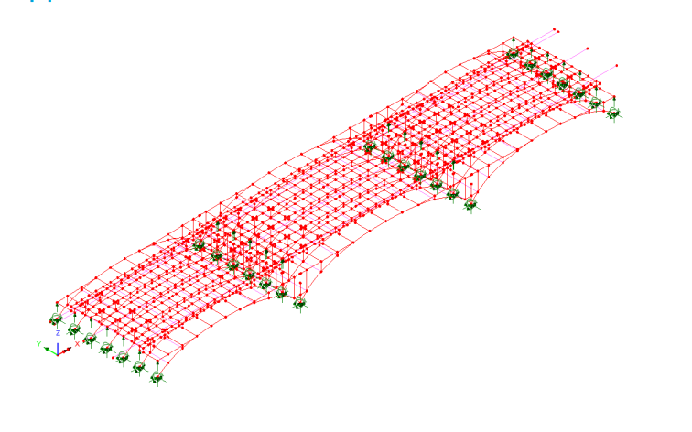

Three-dimensional beam element model - 2022

*“The above analysis found that the footway slab was found to be marginally adequate and the masonry parapets were unlikely to be adequate to sustain the forces from a collision load. Consequently, an accidental wheel load mitigation strategy was required to reduce the risk of an errant vehicle on the footway.”[12]*

## Part 2b – Technical Design: Substructure

### Cofferdams

The actual arrangement of the bridge foundations and temporary works, including the cofferdams around the central piers, is shown below and described in detail elsewhere.

Hampton Court Bridge cofferdam arrangement at the south river pier

Typical arrangements for cofferdams placed in water and also deep excavation in ground are shown below.

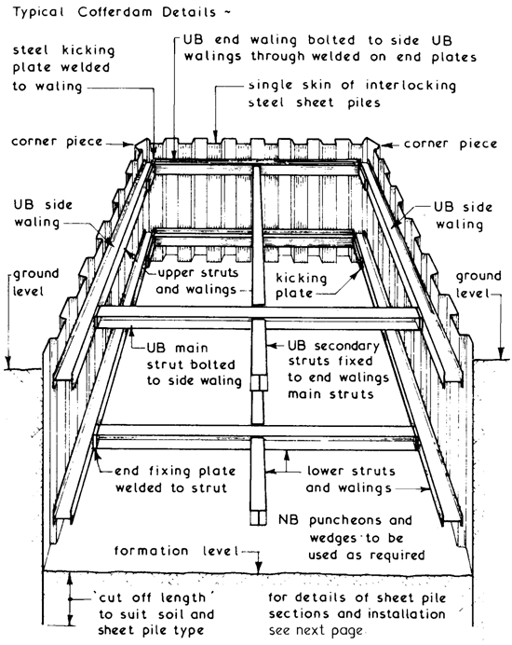

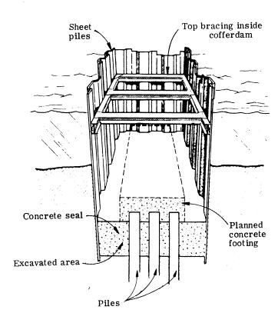

Typical cofferdam arrangements

### The Influence of “Soils” on Substructures

In soil mechanics, a soil was (and is) regarded as material originally produced by the disintegration of rocky portions of the earth’s crust. Through deposition, consolidation and settlement through still water, consolidation by pressure, or dispersal and grading by the action of moving water, the final product is the clay, sand, marl, gravel or other soil, which forms or supports the works of civil engineering.

Soils impose forces, both locally on the walls of the cofferdam, and on the structure as a whole, thus adding to loads from hydrostatic and dynamic forces from the river. Local forces are a major component of the lateral forces on the sheet pile walls, causing bending in the sheet piling and walings, and axial compression in the horizontal struts.

Apart from resisting the horizontal forces acting on the sheet piles, an additional consideration was to prevent water seeping through the bottom of the excavation, which the concrete seal prevents. In extreme cases, the loss of strength in a river bed could lead to spontaneous liquefaction, requiring other temporary measures.[13] In modern times, these include dewatering and ground freezing.

To assess the behaviour of the river bed, it was agreed by Thames Conservancy in October 1927 that borings could be made, in order to extract samples. The science of soil mechanics could then have been used to test the material’s strength and likely behaviour under the conditions it would experience. For example, would it be strong enough to resist the forces from the bridge piers without using piling?

There is no information on how soil mechanics was, in fact, used in the design of foundations for the Hampton Court Bridge. However, the science was well developed at the time and the following description indicates the knowledge then available.[14]

Ignoring organic deposits, the two main soil classifications used for analysis and use are sand and clay. Each contains particles which have their own detailed classification and size grading distribution. Their engineering properties and characteristics are further complicated by other factors including clay mineral properties, water content and associated liquid, plastic and shrinkage limits, voids ratio and porosity.

A combination of all these factors leads to the overall strength of a soil. This is based on its resistance to shearing forces and its maximum resistance to shearing stresses. Once exceeded, failure occurs, usually taking the form of surfaces of slip. The law governing shear failure in soils, generally known as Coulomb’s Law, was first put forward in 1773. This provides a simple relationship between shear strength, cohesion, applied stress and angle of friction at any given point in the soil. Using the principles of stress analysis, which we saw applied to an element of material in the design of concrete above, Coulomb’s Law can be depicted conveniently by Mohr’s Circle of stress. This representation is used in laboratory tri-axial soil tests. These enable shear strengths to be determined experimentally for different conditions of drainage of a soil sample.

It is not known whether tri-axial tests were used for Hampton Court Bridge, as they would have been considered “state of the art” at the time. However, an alternative method that was commonly used for assessing soil strength was the “probing bar” or, as it is currently known, “standard penetration test.” Typically, a 2ʺ diameter tube is driven about 18ʺ into the ground below the bottom of the borehole and the number of blows required to cause 12ʺ of penetration forms a guide to the resistance of the stratum, the first 6ʺ of penetration being ignored. The results become relatively less reliable as the soil becomes more cohesive.8

Typical allowable bearing pressures used for foundations at the time, are shown in the following table.

|  |  |
| --- | --- |
| Foundation bed | Tons/sq.ft. |
| Moist sand, soft clay | 1 |
| Dry sand and clay mixed | 2 |
| Firm dry sand, firm clay | 2-3 |
| Firm gravel, coarse hard and compact sand, very hard clay, firm chalk | 4-5 |
| Shale in level beds, hard pan | 6-8 |
| Rock | 8-100+ |

### Scour and Seepage under Cofferdams

Whenever the water level in a river rises, the river bed starts to move throughout the greater part of its length and width, and the bottom of the river goes down. This process is known as a scour and the failure of bridge piers, due to this cause, is not uncommon. Hence, the base of the foundation should be several feet below the level to which the river may scour during high water and placed on top of a concrete seal, with or without piles.

If a seal were not provided, seepage of water under the temporary cofferdam sheet piles can occur. Seepage flow diagrams could have been prepared to estimate the direction, speed and quantity of water flow. In the following diagram, which shows a typical arrangement of sheet piles, lines AB and CD join up soil particles experiencing the same pressure (an equipotential line) and AC and BD show two different pathways of elements of water (flow lines.)9

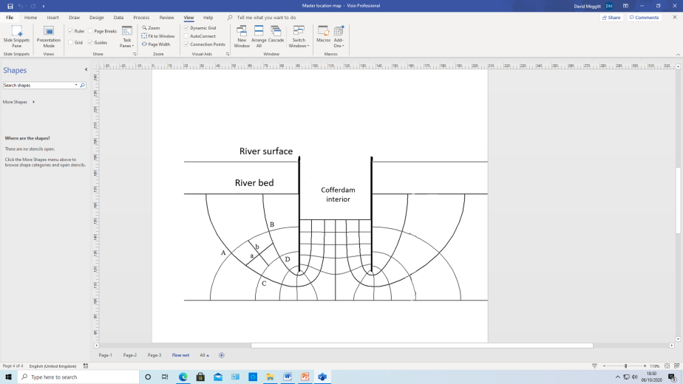

Seepage flow diagram around cofferdam

These diagrams are a graphical representation of an algebraic expression known as Laplace’s equation 9 [15]. The equation applies to the flow of every incompressible fluid through an incompressible porous material of given permeability. The flow is also considered to be two dimensional. Although flow nets can be constructed graphically, they are commonly supplemented by computational methods. This approach would have been known when Hampton Court Bridge was constructed, following the original work in hydraulics by the Austrian civil engineer Philipp Forchheimer, who died in 1933.

The permeability of a soil is measured in the laboratory using a permeameter.

Again, it is not known whether any of the above fundamental soil mechanics techniques were used for the temporary and permanent designs at Hampton Court.

## Part 3 – Virtual Connections

The idea of “virtual” or “least” work has been constructively used in structural analysis and design for almost 150 years. Interestingly, a new word association for “virtual” has emerged in recent years.

A potential synergy between the two applications of “virtual” is now explored; that between technical design and organizational design.

### Virtual work in structural analysis

The general procedure is based on the following principles:-

When a system of forces which is in equilibrium undergoes any set of arbitrary, virtual, displacements the total work done is zero. The displacement is called virtual because in need never really occur; it is sufficient to visualize such a displacement and to see that if it did occur then the total work-virtual work-would be zero.

The associated forces are also assumed to remain constant during the virtual displacements, i.e. the forces and displacements are not necessarily cause and effect, and may never occur together. However, the choice of displacement direction should be realistic.

The above can be used to calculate the deformation of structures under loads. The work done on, for example a joint, by external forces is balanced by the work done on a member. This can be summed for all joints and members. As the total work done is zero, individual member forces and deformations can be calculated.

In general, a structural member can be subject at any section to the six stress resultant actions comprising an axial force, shear forces and bending moments. Fortunately, only one or two actions predominate and need to be considered.

The above principle is a special case of **the Principle of Least Work** typically applied to plates. This requires a comprehensive analysis using partial differential equations to determine when strain energy is a minimum.

Historically, the concept of virtual work falls into the category of energy theorems initially developed by Castigliano for purely elastic members with linear load-displacement diagrams, published in 1879.

### Virtual worker in organizations

The rise of technology and the need for flexible working has led to the emergence of hybrid virtual work organizations, which are becoming increasingly adopted. In parallel, “emergent” configurations such as Teal and Holocracy have evolved.

Virtual work organizations do offer many benefits, including flexibility, cost savings, and access to a wider talent pool. However, they also present challenges, including the need for mind-set changes in assessing new organizational configurations, the ongoing impact of COVID-19, and the neuroscience underpinning working relationships. By understanding and addressing such challenges, virtual work organizations can be successful and thrive in the future. Is this transition from old to new management thinking a manifestation of a permanent shift to cope in the information age?

|  |  |  |
| --- | --- | --- |
| **Views of managerial thinking** | | |
| Factor | **Old** Management Thinking | **New** Management Thinking |
| Time is | One thing at a time | Many things at once |
| Growth is | Linear, managed | Organic, chaotic |
| Change is | Something to worry about | All there is |
| Workers are | Specialised, segmented | Multi-faceted, always learning |
| Knowledge is | Individual | Collective |
| Information is | Ultimately knowable | Infinite and unbounded |
| Life thrives on | Competition | Cooperation and Collaboration |
| Organization is | By design | Emergent |
| Managing means | Control, predictability | Insight, participation and flexibility |
| Motivation is from | External forces and influences | Intrinsic creativity |
| We understand things by | Dissecting into parts | Seeing in terms of the whole |

Traditional (or Old) management approaches, such as command and control, will struggle to be effective in a virtual work environment. Instead, the adoption of a more collaborative and decentralized approach seems apposite. Managers need to trust their employees and provide them with the tools and resources to work effectively in a virtual environment. This does require a shift in mindset from one of control to one that embraces transparent business models featuring People and the Roles they play to co-create Deliverables (results and outcomes).[16]

### Seeing the Work of a Daily Management System - Lean Enterprise Institute

The Death of Command and Control?

### Importance of Working Relationships

To re-emphasize, despite the benefits of virtual work organizations, there are challenges to working in a virtual workplace. For example, communication and collaboration may be less spontaneous and less frequent, leading to feelings of isolation and disconnection. Therefore, it is essential to prioritize building and maintaining effective working relationships. Important because the type of interaction between people ultimately drives organizational resilience and agility, shaped by individual mental models, founded on emotion. [17]

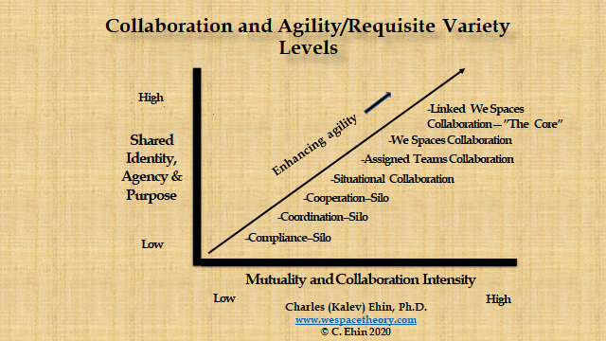

|  |  |  |
| --- | --- | --- |
| **Type / level of interaction between people[18]** | Description | Trust level |
| Collaboration | Sharing of ideas and skills for mutual benefit based on trust and supportive relationships | High |
| Cooperation | Pursuing common goals – (discretionary action) | Low to Medium |
| Coordination | Attaining unity of action –(formal organising) |
| Compliance | Following directives | Nil |
| (Coercion) | Responding to threats |

### A new Organizational Paradigm

It is also evident that any co-creative effort intrinsically relies on People performing designated Roles in a collaborative way.

We also need to scan the horizon for opportunities within the Fitness Landscape as well as make transparent specific processes and informal networks within Internal Transactions.

How useful would it be to have available to Participants a powerful and innovative approach to enhance their efforts to stay competitive in challenging business environments and achieve with others what they are unable to accomplish on their own?

The new EAGLE Organizational Paradigm offers this hope which readers are invited to explore along with the underpinning Value Exchange System (VES).[19]

1. C. E. Inglis, The Aesthetic Aspect of Civil Engineering Design, London: The Institution of Civil Engineers, 1945, p. 47.
2. An integration of methods originally proposed by Cynefin and PA Management Consultants.
3. See, for example, D. Meggitt, C. Sarri and L. Evans, “Using value networks to boost construction performance,” Proceedings of the Institution of Civil Engineers Civil Engineering 165(5), pp. 11-17, 2012.
4. M. Chrimes, “The development of concrete bridges in the British Isles prior to 1940,” Proceedings of the Institution of Civil Engineers, vol. August/November, no. Structures and buildings, pp. 404-431, 1996.
5. A. Pippard and J. Baker, The Analysis of Engineering Structures, London: Edward Arnold Ltd., 1957, pp. 258-301.
6. S. Timoshenko and D. Young, Elements of Strength of Materials, Fourth ed., Princeton, New Jersey: D. Van Nostrand Company, Inc, 1962.
7. F. Newby, “The innovative uses of concrete by engineers and architects,” Proceedings of The Institution of Civil Engineers, vol. August/November, no. Structures and Buildings, pp. 264-282, 1996.
8. J. Faber and F. Mead, Oscar Faber's Reinforced Concrete, London: E.& F.N. Spon Limited, 1961.
9. Extract from: “Hampton Court Bridge Through the Ages – The Story of the Crossings over the River Thames at Hampton Court.”Published by the Molesey Local History Society, 2024
10. C. S. Chettoe and H. C. Adams, Reinforced Concrete Bridge Design, London: Chapman & Hall Ltd., 1938.
11. Courtesy Surrey County Council.
12. “Assessment of Hampton Court Bridge,” Surrey Highways, Kingston-upon-Thames, 2022.
13. K. Terzaghi and R. B. Peck, Soil Mechanics in Engineering Practice, London: John Wiley & Sons, 1948.
14. P. Capper and W. Cassie, The Mechanics of Engineering Soils, 4th ed., London: E.& F.N. Spon, 1963.
15. E. Kreyszig, Advanced Engineering Mathematics, London: John Wiley & Sons Inc., 1962.
16. See, for example, <https://ves.ghost.io/> last accessed 11th Aug 2024.
17. <https://ves.ghost.io/probing-the-robustness-of-human-interactions-h5-a3/>
18. See Ehin, Charles, Expanding "We Spaces," Narrowing the Management Paradox, Salt Lake City, Utah: Bookbaby, 2020.
19. <https://ves.ghost.io/the-new-eagle-organizational-paradigm-d6/>